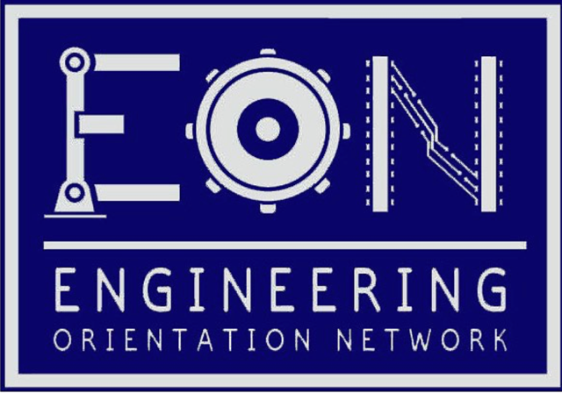

Welcome to Penn State’s College of Engineering! First off, congratulations! To ease your transition into the college, the Engineering Orientation Network (EON) will provide you with multiple informational sessions, fun activities, and helpful mentors. Our entire team looks forward to providing you with all the insight you need in order to become comfortable with this new experience. While we usually hold an all-day orientation, we have altered our event schedule to align with Penn State’s COVID-19 guidelines. We are excited to offer the events below this year to welcome you to ‘Happy Valley’ ~ WE ARE Penn State!

Check out the events we have listed below to see what we have to offer!
EON 2021 Welcome Bag (July-August)

When you sign up for EON we will be sending you some gear for the coming school year!
EON will be sending out the welcome bags through July and August as supplies last, so make sure to sign up! The first 100 to sign up will get a 3D Printed EON keychain made by the Maker Commons.

Mentor/Mentee Pairings:

Through EON, each incoming student is placed with a mentor who will provide their group of mentees (you!) with important information, including EON event details, resources, and general class questions. Your mentor will also be able to answer any questions you may have, and since each mentor will have a group of mentees, this will also give you a chance to meet and interact with other incoming students. Your mentor will also be a resource for you all semester long as you embark on your Penn State journey!

By signing up for EON (or if you already have), your mentor will reach out to you a week before classes start to get to know them better and you will meet them at our Dean’s Welcome Watch Party!
Dean’s Welcome Watch Party & Engineering Club Fair:

The Sunday before classes start (August 22nd), the College of Engineering’s Dean of Students will be welcoming all incoming engineering students. The Dean’s speech will provide important information about the college and different events occurring throughout the semester.

To make the Dean’s speech more interactive and give you the ability to meet some of your peers, we decided to host a watch party for it! You will meet up with your mentor and fellow group of mentees on campus to watch, have some snacks, and compete in a design competition!

Directly following the Dean’s speech on August 22nd, EON will be hosting an Engineering Club Fair. Most of the engineering clubs on campus will be in attendance and are more than happy to answer questions you may have, or can simply give you a rundown of the various activities they engage in. Joining a club is a great way to meet new people who share a common interest, which may be especially difficult with the lack of in-person contact this semester. No matter your interest, you should be able to find a club that interests you! The club fair logistics are still in the making. As soon as we know, you’ll know!

EON 2021 Welcome Panel

During the first week of classes EON will host a student panel complete with engineering students at each level of their education. The panel will discuss Penn State Engineering, job/internship search, campus life, their growth during their time at Penn State, their involvement, as well as answering any questions you ask LIVE!

If you have any questions, please feel free to reach out to:

Johannah Fink, EON 2021 President at jnf5202@psu.edu

We look forward to welcoming you into Penn State’s College of Engineering!

Sincerely,

The EON 2021 Executive Board

